User Guide to the Cyber Education Hub™

Table of Contents

BLUF: 1

From the Welcome page 2

From the User Home Page 2

Viewing a content Item 4

Local Video Playback 5

Search 5

Navigation Bar 6

Contribute Content 7

Adding a file 7

Drag and Drop 7

Click and Find 7

Link to external content 8

Adding metadata to a content item (Edit a content item) 9

Adding a Topic from the Topic Map 10

Save and Submit 11

Topic Map 11

KSA Trees 12

Submit Feedback 14

Help 14

Editing My Profile 14

User Login from Various Browsers 15

Chrome 15

Internet Explorer 17

Edge 18

Firefox 20

# BLUF:

**Use Google Chrome when possible. As a second option, use Internet Explorer. Avoid Edge and Firefox for accessing the Cyber Education Hub website.**

If it is your first time accessing the Cyber Education Hub, you are using a new browser, or want a general walkthrough of accessing the site go here: Ctrl+Click -> *Registered User Login from Various Browsers*

# From the Welcome page



If you are NOT registered: Click on “Register Now” and select the “DOD ID” cert when prompted

If already registered: Click on “CAC Sign In” and select the “DOD ID” cert when prompted

(Note: DO NOT select “EMAIL” cert)

(Note: “ENTER” Button may not yet function”)

# From the User Home Page

Please note the Beta Banner. “The platform is still in development and there may be intermittent performance issues. We would appreciate ANY input you have related to the current and future state of the Cyber Education Hub. Look for the ‘Submit Feedback’ button at the top of the Page. Thanks!”

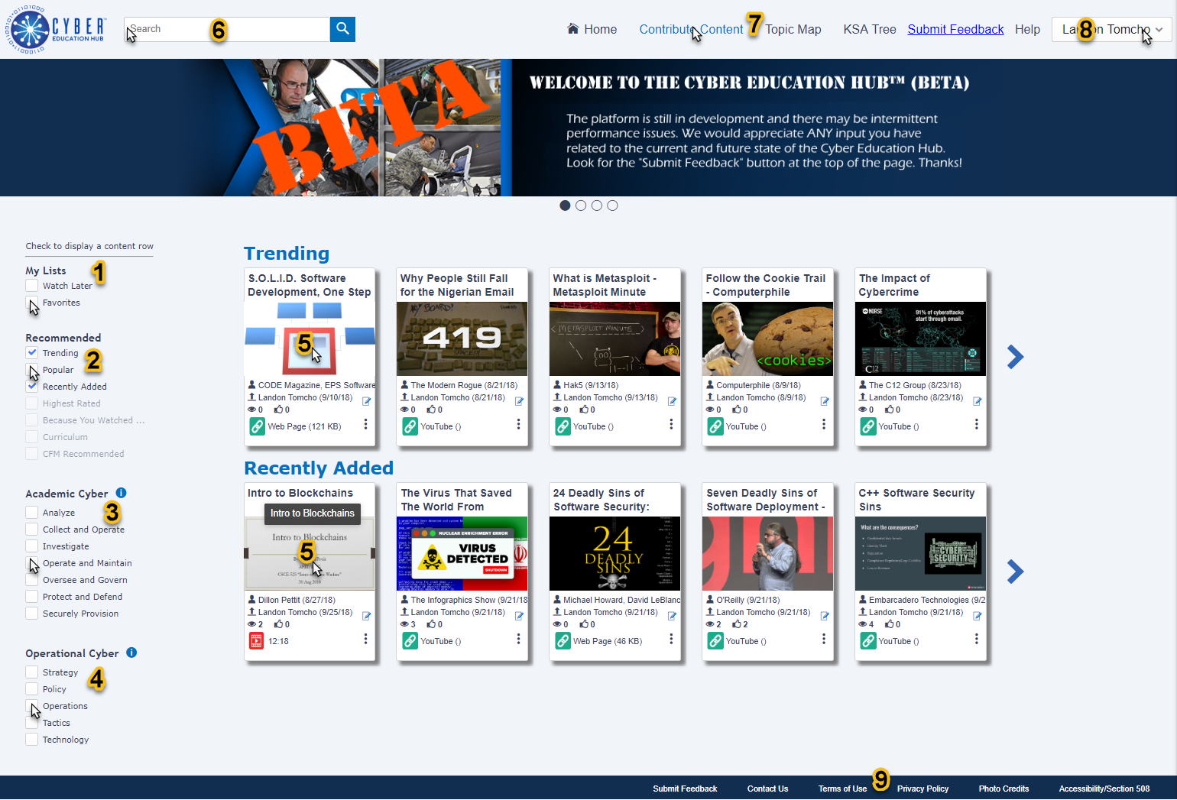

From the user home page, you can do many things including:

1. See content in ‘My Lists’
   * For 1-4, click the checkbox of the category, and wait for the content to populate
2. See different types of ‘Recommended’ content
   * Some categories are coming soon and are currently ‘grayed out’.
   * ‘Trending’ and ‘Popular’ algorithms may not yet be implemented.
3. See content in different ‘Academic Cyber’ categories
4. See content in different ‘Operational Cyber’ categories
5. View a content item
   * Click on the item you wish to view
   * Clicking the ‘three dots’ brings up the options to ‘Add to Watch Later’ or ‘Add to Favorites’
6. Search
   * Type a phrase or keyword and click on the magnifying glass icon
7. Navigation Bar
   * Each Navigation Item is detailed later
8. Profile Menu
   * This brings up the options to
     + Logout
     + View ‘My Content’
     + View/Edit ‘My Profile’
9. Footer
   * Many of these links are not currently functional in the Beta version.

# Viewing a content Item

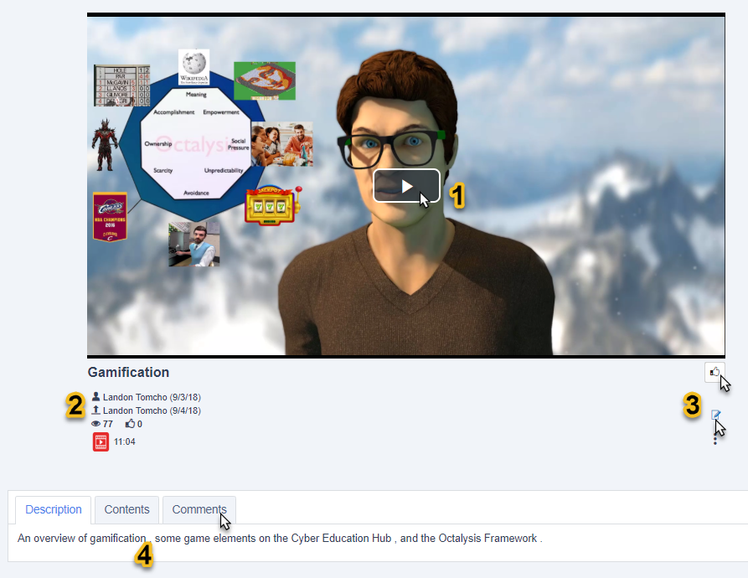

1. Play the video, Download the File, Go to the external link
2. Content Information
   * The top name is the content creator/author
   * The second name is the content uploader (happens to be the same in this case)
   * The next row shows view count and like count
   * The bottom item shows the content type (local video in this case) and the associated time or file size
3. Other Actions
   * Click the ‘Like Button’
   * If you own the content, you can click the blue ‘Edit’ button
   * The three dots bring up other functionalities including “Add to Watch Later’
4. More information
   * Description Tab
   * Contents Tab – some content items have a table of contents that takes you to certain points in the video when clicked
   * Comments Tab – post and view user comments

## Local Video Playback

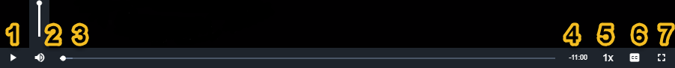

1. Play/Pause Button
2. Volume Control
3. Video Time Indicator and Selector
4. Time Remaining
5. Playback Speed
6. Closed Caption Options
7. Fullscreen Option

# Search



Click on the “Search” bar in the top left of the page. Type in a keyword or phrase and click the Magnifying Glass Icon.

(Hint: adding more words makes the search more restrictive, if you can’t find what you’re looking for, try being less specific)

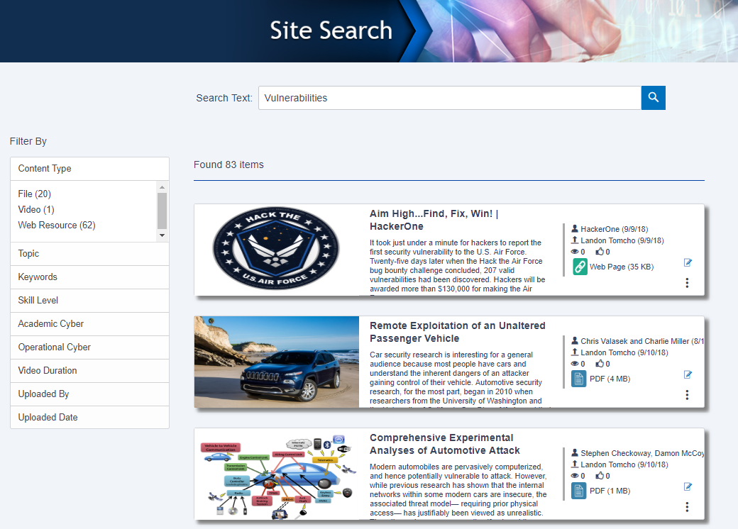

Next, scroll through content items, read descriptions, and select what you want to view.

The filters on the left side can be clicked to see metadata features of the items that appeared in the search, but currently, these elements do not add an additional filter to the search (feature coming soon!)

# Navigation Bar

Located on the top of the page.

* Home – takes you to the “User Home” page
* Contribute Content – allows you to contribute videos, presentations, documents, web links, etc. to the Cyber Education Hub community
* Topic Map – Explore and test out a new and unique way to navigate content
* KSA Tree (Knowledge Skill and Ability Tree) – Develop yourself and track your accomplishments by completing challenges and activities, check it out!
* Submit Feedback – Let us know about any issues and/or ideas for the Cyber Education Hub website.
* Help – feature coming soon.

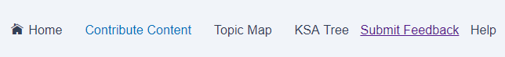

# Contribute Content

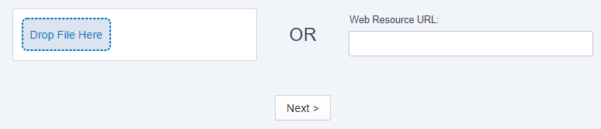

Add a file OR a link to an external content item.

## Adding a file

Drag and Drop OR Click and Find

### Drag and Drop

Be sure to drop within the blue box.

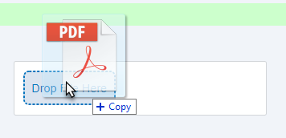

Wait for upload and click ‘Next’

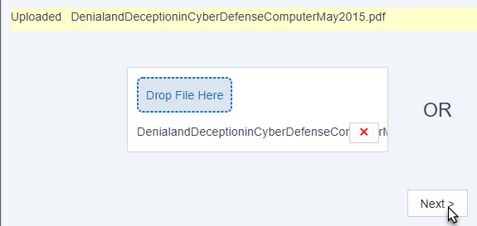

### Click and Find

Be sure to click inside the blue box.

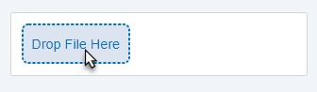

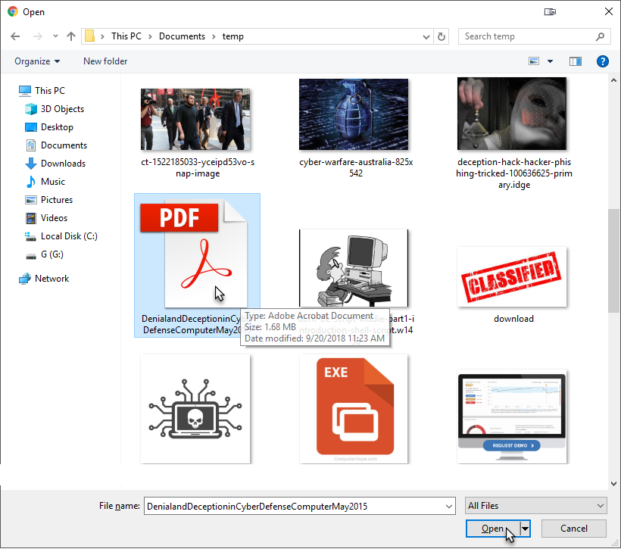

Wait for upload and click ‘Next’



## Link to external content

Copy URL of desired content (Easter Egg?)



Paste into “Web Resource URL:” box and click ‘Next’.

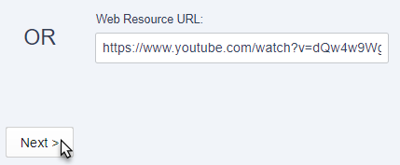

## Adding metadata to a content item (Edit a content item)

Some metadata will auto-populate, based on what is supplied by the file or web-page. Other details should be filled in by you, the uploader. (Hint: If you are more descriptive and thorough with the keywords/categories/etc., your content item will be found more often in appropriate searches, resulting in more views).

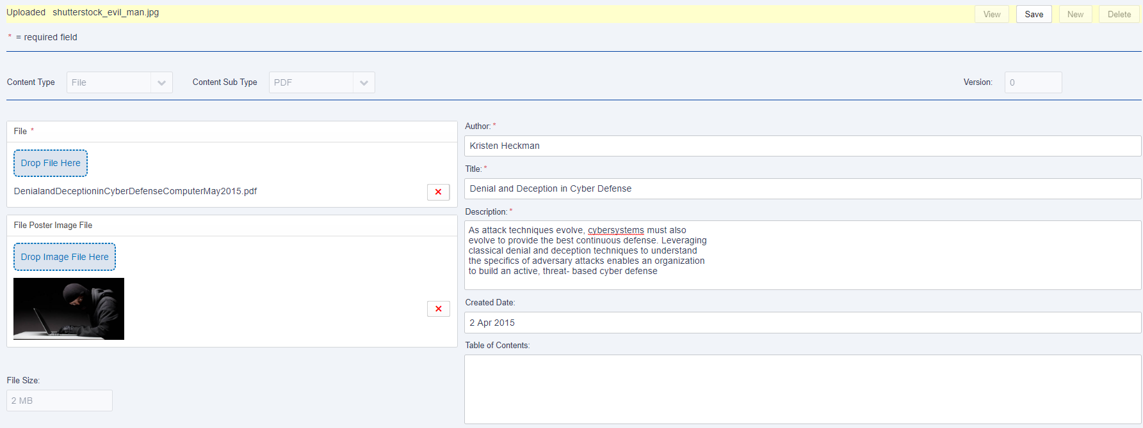

If an image file is not auto-populated, you should consider adding a poster image. (Hint: users are more likely to view content that has more than the default content item poster). To add an image, you can Drag and Drop or Click and Find (just like adding a file content item: see previous subsection). Remember, be sure to click or drop within the blue box!

### Adding a Topic from the Topic Map

Find the appropriate topics and subtopics for your content item on the Topic Map and click the appropriate nodes to create the topic association. As you get to know the Topic Map better, it will be easier to find the appropriate topics. (Future feature: being able to search for topics in order to add them to the content item. Hint: for now, ctrl+f is a workaround).

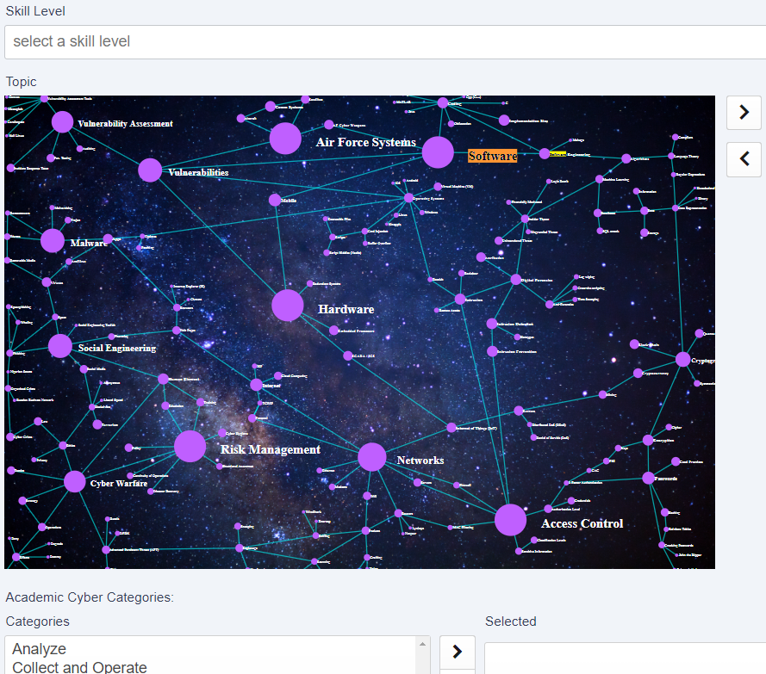

If you don’t have a mouse wheel to zoom in/out you can zoom out with SHIFT + double click and zoom in with CTRL + double click. You can also pan by click + drag.

Please be patient when adding topics, sometimes you may have to wait a couple seconds before the topic appears on the right side. If you accidentally add a topic twice or add the wrong topic, you can click on the text and click the Left arrow to remove the topic.

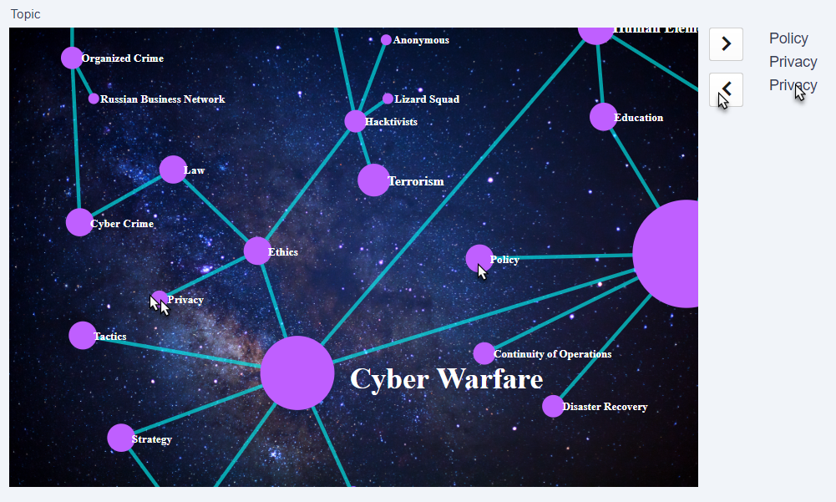

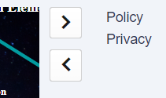

## Save and Submit

When finished adding details about the content item, go to the top of the page, hit ‘Save’, and wait for the bar to turn green. To preview the content, click ‘View’. If you wish to add another content item, click ‘New’. To Delete the content item, press ‘Delete’ (you can also do this later from the blue ‘Edit Button’ mentioned earlier.





# Topic Map

Explore the Topic Map and discover available topics and their relationships. For now, the Topic Map is static, but will certainly evolve. If you don’t have a mouse wheel to zoom in/out you can zoom out with SHIFT + double click and zoom in with CTRL + double click. You can also pan by click + drag. As you get to know the Topic Map better, it will be easier to find the appropriate topics. (Future feature: being able to search for topics. Hint: for now, ctrl+f is a workaround). Once you find a topic you want to explore, simply click it, and associated content will populate on the right side of the screen.

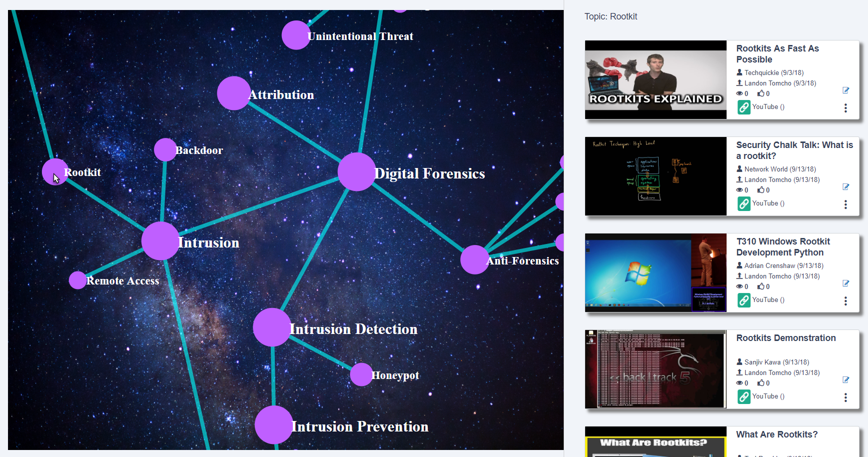

# KSA Trees

Click the dropdown to see a list of available trees, select, and wait for the tree to load.



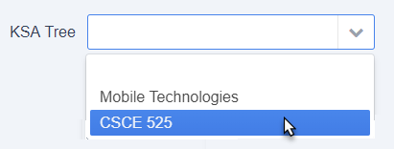

The first time you access your tree, you will see Yellow and Red shapes/icons. For different trees, different shapes/icons can mean different things. But for now, the meaning of the colors is persistent. Yellow means that a node is ‘Unlocked’ (Different trees may have a different number of initially Unlocked nodes). You are able to click on Unlocked nodes and see the associated challenges/tasks/activities available to develop your knowledge, skills, and abilities (hence the KSA Tree).

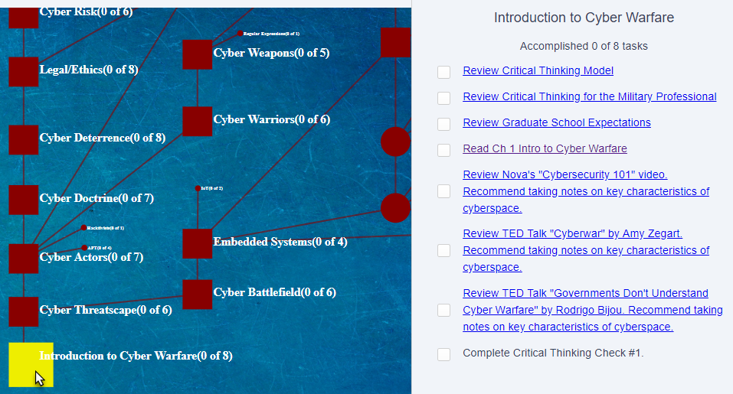

The Red nodes are ‘Locked’ and cannot be accessed until Unlocked by turning a neighbor node into a Green partially/fully ‘Completed’ node. In order to turn a node Green, you must complete a number of the tasks within an Unlocked node. Some tasks are highlighted and underlined in blue. This means that you can click on them and the associated content will open in a New Tab. This allows you to keep your place on the tree without having to re-navigate pages.

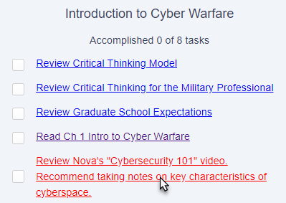

When the task threshold is met, neighboring nodes are Unlocked. The count next to the node name allows you to see the accomplished X tasks out of the total Y Tasks: (X of Y). Just like with the map, you can pan with click + drag, zoom in with ctrl + double click, and zoom out with shift + double click.

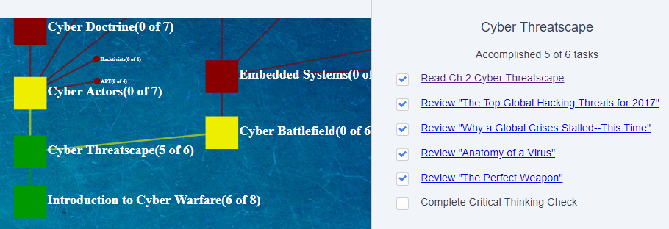

# Submit Feedback



If you have any issues with the site, a piece of content, etc. click the “Submit Feedback” link at the TOP of the page. Depending on the current version, you may get a popup with an email address to contact, or be taken to a feedback form. Emailing [landontomcho@gmail.com](mailto:landontomcho@gmail.com) may result in a quicker response, but you should optimally do both the email and fill out the form.

If you have any ideas for improvements, or future features for the website, please send this feedback in the same manner. Your comments are welcome and appreciated!

# Help

If you need help, check out the contents of this document, Submit Feedback, or contact [landontomcho@gmail.com](mailto:landontomcho@gmail.com)

# Editing My Profile

Click on your name in the upper right-hand corner of the page. Click on ‘Profile’ in the dropdown menu.

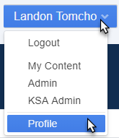

Most fields are text fields that can be easily edited. If editing your name to make it lower-case, ensure that your Real Name is still used. When selecting rank, you may have to scroll down or down-arrow through the options to find rank above E-7. Ensure a valid email is entered, this ensures that we can respond to your feedback and help requests. If unfamiliar, please avoid editing the “User Home Selected Rows” field. In order to add an Avatar Image, you may either Drag and Drop or Click and Find.

# 

# User Login from Various Browsers

These Instructions are for Registered users, unregistered users will have a slightly different process when after the Website welcome page is reached.

### Chrome

1. Enter URL
2. “Your connection is not private” Warning

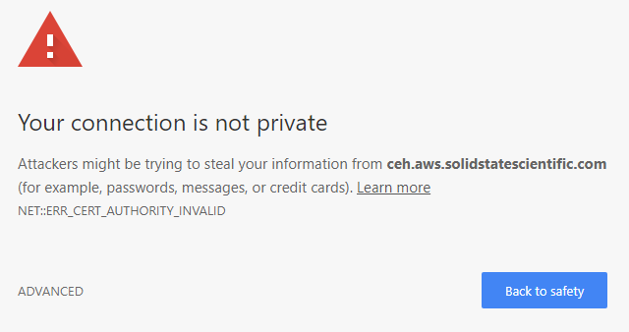

1. Click “Advanced”

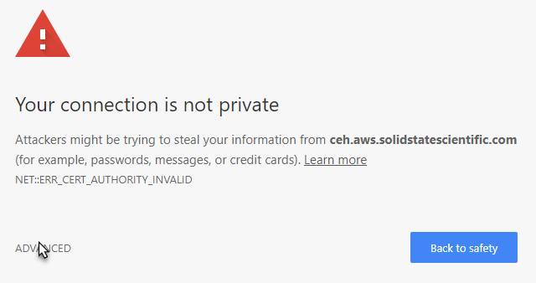

1. Click “proceed to site”

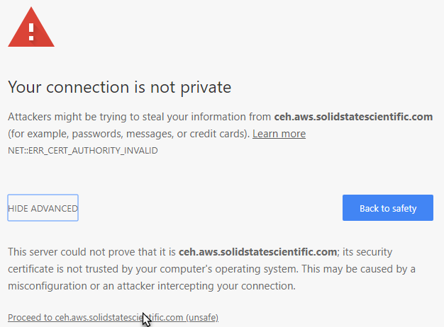

1. Select “DOD ID” certificate and click “OK”

(Note: DO NOT select “EMAIL” cert)

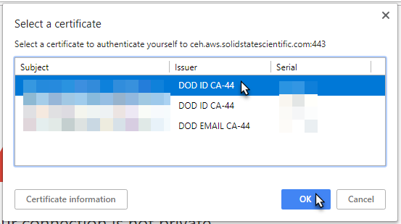

1. Enter CAC PIN

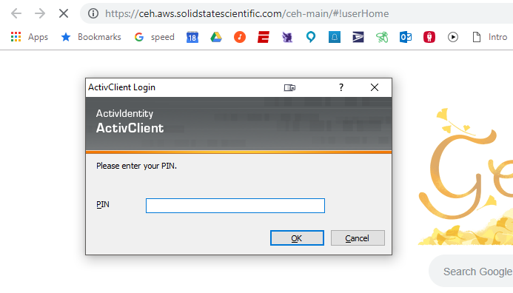

1. Wait (“Page isn’t working”)

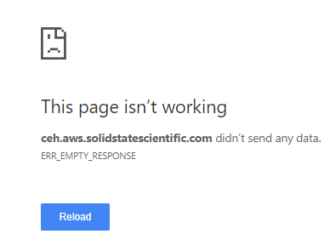

1. Success!

### Internet Explorer

1. Enter URL
2. “This site is not secure”

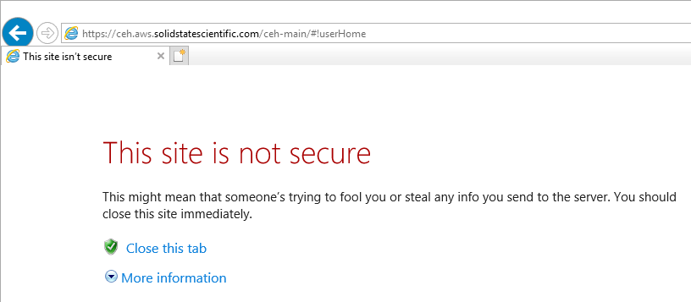

1. Click ‘More information’

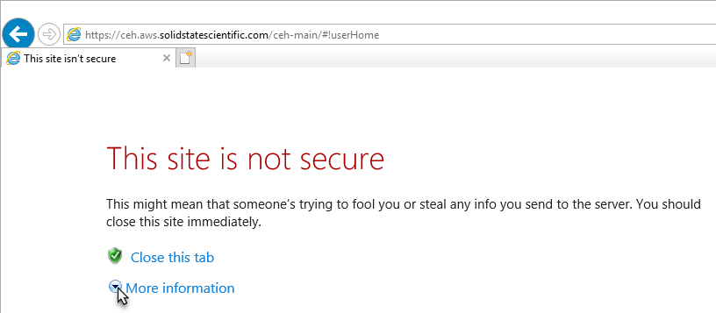

1. Click ‘Go on to the webpage’

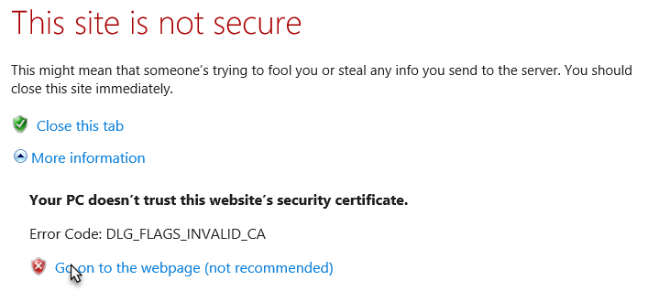

1. Select ‘DOD ID’ certificate and click ‘OK’

(Note: DO NOT select “EMAIL” cert)

WARNING: When using Internet Explorer, the following Window often appears Underneath the browser window. You may have to go find it.

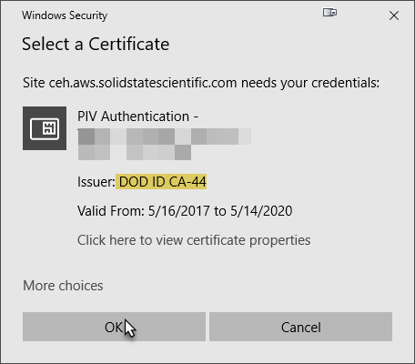

1. Enter PIN

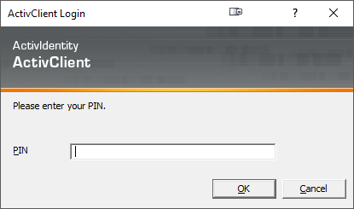

1. Success!

### Edge

1. Enter URL
2. “This site is not secure”

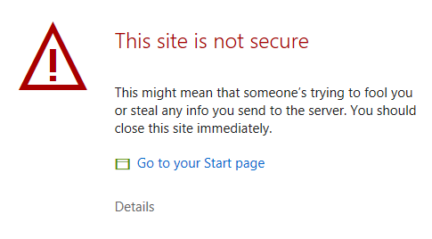

1. Click “Details”

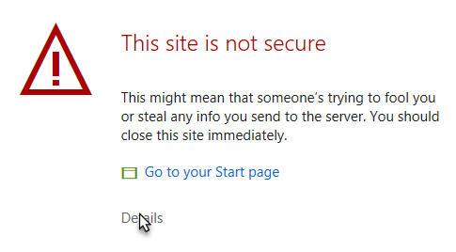

1. Click “Go on to the webpage”

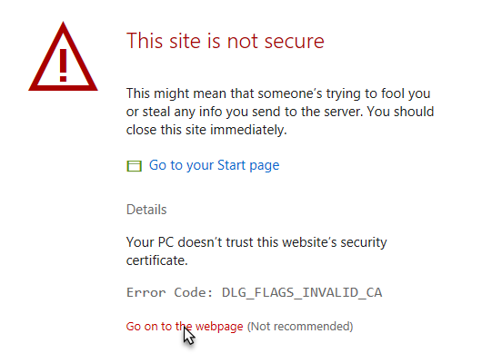

1. Select “DOD OD” certificate and click “OK”

(Note: DO NOT select “EMAIL” cert)

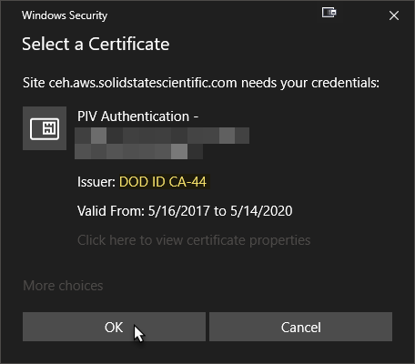

1. Edge closes or gets a “Can’t connect securely to this page” error. Use Chrome

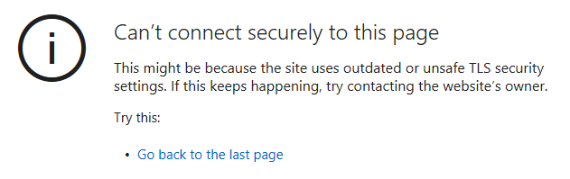

### Firefox

1. Install Firefox
2. Enter URL
3. “Your connection is not secure”

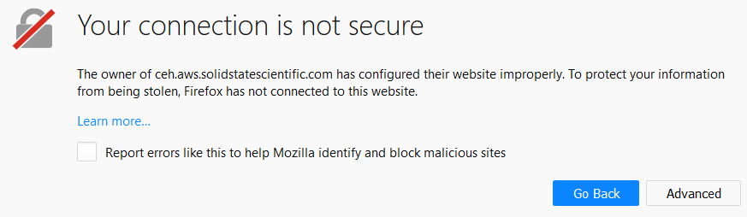

1. Click “Advanced”

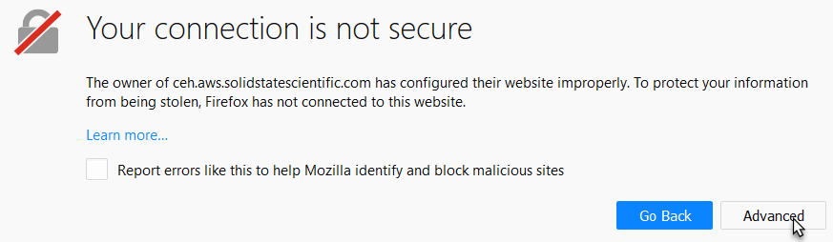

1. Click “Add Exception”

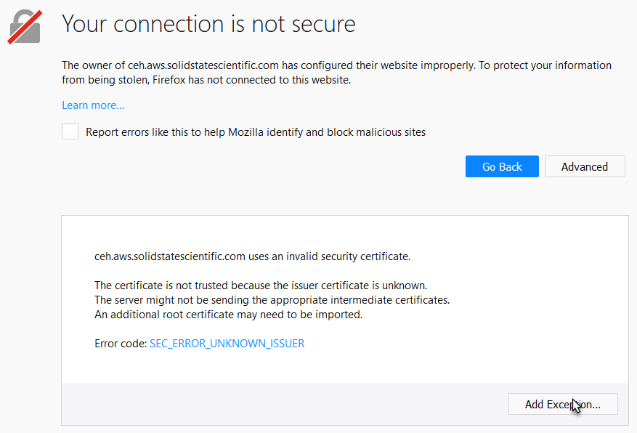

1. Click “Confirm Security Exception”

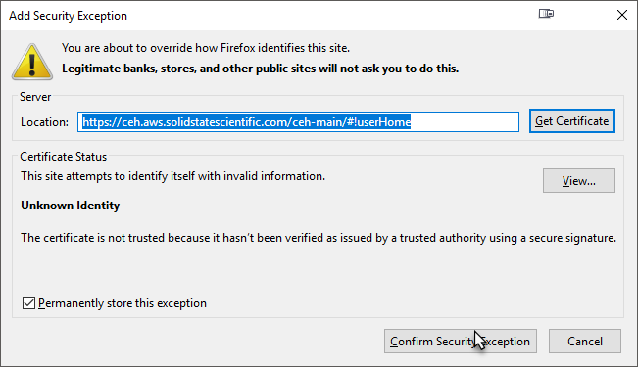

1. Connection Fails, Click “Try Again”, Connection fails again.

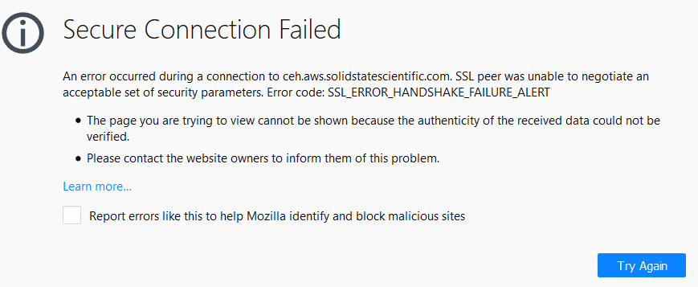

* 1. Try to add another exception with full URL, says no exception needed. Still won’t work even after restarting browser.
  2. 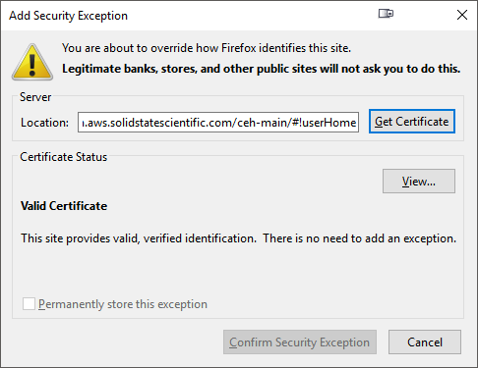
  3. Uninstall Firefox. Use Chrome.

Notes

You cannot add a security exception in Edge (at least based on my research).

You can add an exception in Firefox, but it doesn’t work in the end.